*Course title: Computer Graphics Lab*

*Course code: CSE-304*

*3rd Year 1st Semester Examination 2022*

**Date of Submission**: 4 June 2023

**Submitted to**

**Dr. Mohammad Shorif Uddin**

*Professor*

**Dr. Morium Akter**

*Associate Professor*

*Department of Computer Science and Engineering Jahangirnagar University*

*Savar, Dhaka-1342*

**Sl** Class Roll Exam Roll Name 01 408 202220 Sudipta Singha

**MIdpoint:**

**#include<graphics.h>**

**#include<math.h>**

**#include<stdio.h>**

**int main(){**

**float A=300;**

**float B=300;**

**int Gdriver=DETECT,Gmode;**

**initgraph(&Gdriver,&Gmode,"");**

**float R=200;**

**float x=R;**

**float y=0;**

**float P=4.0/5.0-R;**

**putpixel(0+A,R+B,RED);**

**putpixel(0+A,-R+B,RED); putpixel(R+A,0+B,RED); putpixel(A-R,0+B,RED); while(x>y){**

**y++;**

**if(P<=0){**

**P=P+2*y+1;**

**}else{**

**x--;**

**P=P=2*y-2*x+1;**

**}**

**if(x<y)break;**

**putpixel(A+x,B+y,RED); putpixel(A-x,B+y,RED); putpixel(A+x,B-y,RED); putpixel(A-x,B-y,RED); putpixel(A+y,B+x,RED); putpixel(A-y,B+x,RED); putpixel(A+y,B-x,RED); putpixel(A-y,B-x,RED); }**

**delay(10000);**

**closegraph();**

**return 0;**

**}**

**SCREENSHOT:**

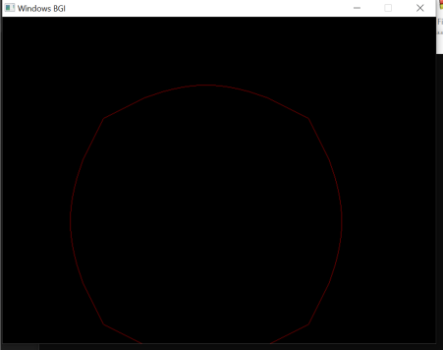**ELLIPSE:**

**#include<graphics.h>**

**#include<iostream>**

**using namespace std;**

**int main(){**

**int Gdriver=DETECT,Gmode;**

**int x;scanf("%d",&x);**

**int x_rad;scanf("%d",&x_rad);**

**int y;scanf("%d",&y);**

**int y_rad;scanf("%d",&y_rad);**

**int start_angle;scanf("%d",&start_angle);**

**int end_angle;scanf("%d",&end_angle);**

**initgraph(&Gdriver,&Gmode,"");**

**ellipse(x,y,start_angle,end_angle,x_rad,y_rad);**

**delay(10000);**

**closegraph();**

**return 0;**

**}**

**SCREENSHOT:**

